|  |
| --- |
| ***About Geno Hr Solution*** |

GENO HR Solution is one of the leading consultancy in INDIA, we provide our professional and personalized services of **HR Consultancy and recruitments**.

 We at Geno HR assist organizations to Search and Recruit the required Quality of Executives within agreed parameters of Cost and Time.

We endeavor to assist corporates to meet their requirements with our Systematic Approach, Quality & Speed of Service and Reliability.

The Team at Geno HR consists of professionals with sound Academic Background, relevant Industry/Consulting experience and the necessary understanding of the Organisational Dynamics at various levels.

We at Geno HR believe that in today’s highly competitive and quality conscious business environment, organizations need appropriate personnel across various functions in terms of educational qualifications, experience and personality. We keep pace with the ever-changing world of Information Technology, Hospitality Industry and Telecommunications. And, we have the necessary expertise to tap the Right Talent for the Right Assignment.

We have been instrumental in providing consultancy and recruitment services to **various MNCs and Indian corporate of repute** at *Junior to Senior Levels.*

|  |
| --- |
| ***Why Us*** |

* We are able to create a reputation due to our professional approach, prompt action and right placements and *of course goodwill and trust of reputed clients and candidates.* We have the honor to be on the panel of numerous multinational and Indian companies. Today we are known for our integrity and quality in helping clients to fill all technical and commercial vacancies.
* We have substantial data bank of high profile, professionally qualified personnel. These database is screened by our experts. Apart from this as we have vast experience in recruitments and prompt selection of candidate we have proved ourselves as a potential tool to any sort of staff requirements.
* We give our proper attention to each vacancy and need our client’s cooperation too to understand their company’s profile along with job details of each vacancy.
* Strong project management: to ensure that appropriate candidates are delivered in line with time critical on-boarding strategies, a close liaison with line management throughout the whole recruitment process is eastablished.



|  |
| --- |
| ***Our Values*** |

• Integrity

• Ethical Business Practices

• Conformance to High Quality Standards

• Client Relationship

***Our Vision:***

• To be the best in business

• To redefine quality and create a brand

***Our Approach:***

We adopt a scientific and systematic approach to attain a Person-Organisation Fit and Person-Job/Assignment Fit. Our focus areas are:

Executive Search: This could be General or Specific.

HR Business Process Outsourcing (BPO): These could include Campus Recruitment, Payroll Processing, Project Staffing or Back Ground Verification.



|  |
| --- |
| ***Executive Search*** |

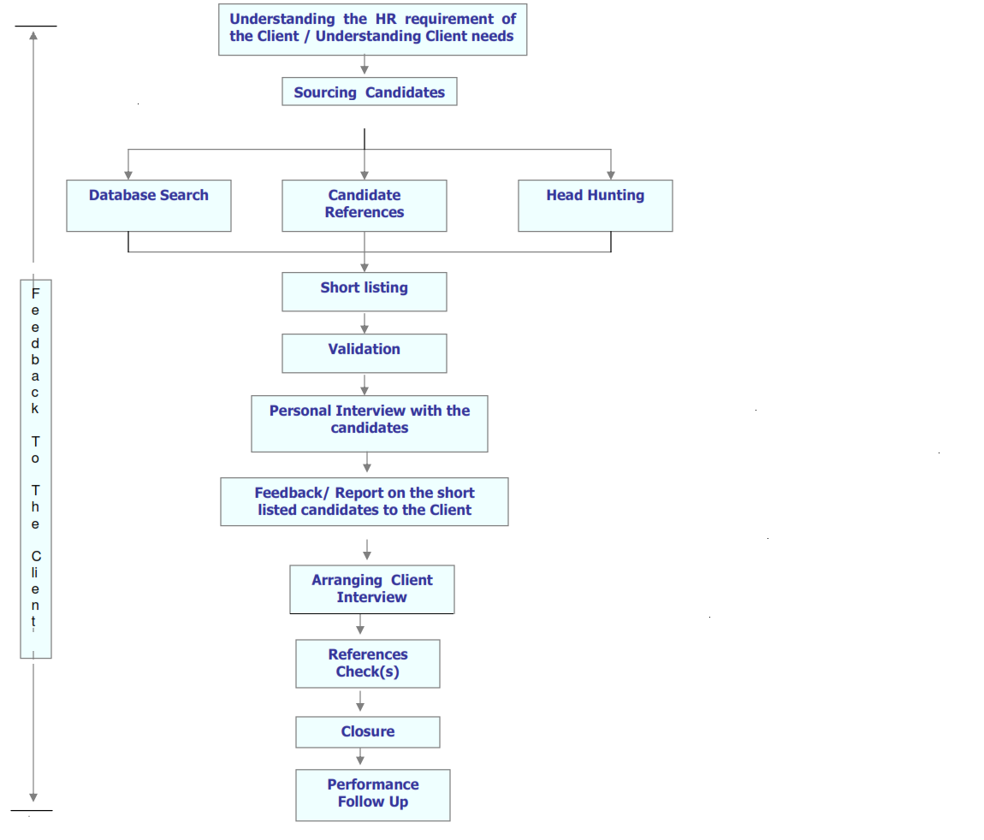

|  |
| --- |
| ***Our Esteemed Clients*** |

   

   

   



|  |
| --- |
| ***Terms and Conditions*** |

1. SELECTION THROUGH TALENT- DATABANK:

We charge a professional fee of 8.33% of the gross annual compensation for each selected candidate from our Talent Data Bank if the selected candidate’s compensation is below Rs. 12 lacs / annum.

For all the selected candidates for whom the compensation is higher or equal to Rs.12 lacs / annum, a professional fee of 12.5% of gross annual compensation and for whom the compensation is higher or equal to Rs.25 lacs / annum, a professional fee of 16.66% of gross annual compensation is payable.

(SALARY means Gross "total cost to the company" and includes Basic + DA + CCA + HRA or market rent of accommodation + conveyance allowance/reimbursement + co. cost / value of all perquisites like car, driver, education, books, etc. and all other allowances / reimbursements / benefits etc., by whatever name called, ... details of perquisite valuations available on request. Service Tax & other government taxes/levies are charged extra, as applicable.)

OTHER TERMS:

1. The client will be responsible for sending to us a copy of the Appointment letter/ Letter of Intent, along-with a statement giving all components of the remuneration package, as soon as these are finalised.
2. The Professional Fees are payable within a fortnight of a candidate joining the company .
3. 3. We would be replacing the candidate if he/she leaves the company within 90 days from the date of joining. The replacement will not be done if the company terminates the services of the employee for whatsoever reason.